🔸 Types of Verb Complement:
# Source: AI Source: Provided by: [Data Path: Persons Table -> ID Column: 1, Name_En Column: Motasem Essam] -> From: [ChatGPT] on [8/4/2025]
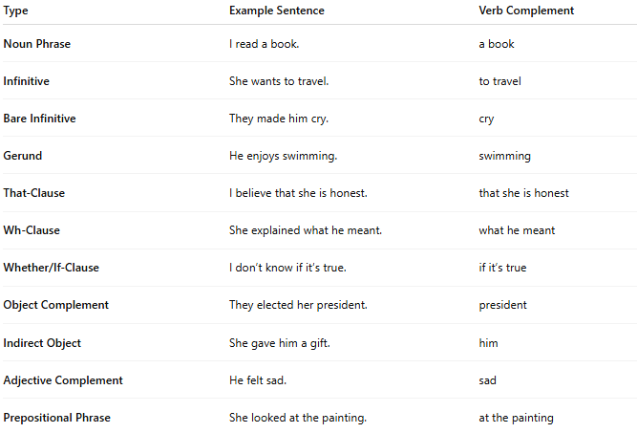

Type | Example Sentence | Verb Complement
Noun Phrase | I read a book. | a book
Infinitive | She wants to travel. | to travel
Bare Infinitive | They made him cry. | cry
Gerund | He enjoys swimming. | swimming
That-Clause | I believe that she is honest. | that she is honest
Wh-Clause | She explained what he meant. | what he meant
Whether/If-Clause | I don’t know if it’s true. | if it’s true
Object Complement | They elected her president. | president
Indirect Object | She gave him a gift. | him
Adjective Complement | He felt sad. | sad
Prepositional Phrase | She looked at the painting. | at the painting

